**Project Merme generator**

**Nicolas Di Costanzo - 21209060**

(nicolas.dicostanzo@ucdconnect.ie)

Contents

Abstract 1

Online Access 2

1. Introduction 3

2. The Core Idea 4

3. Technical Approach: Architectural Perspective 3

4. Data, Information, Knowledge 5

5. Diversity and Divergence 6

6. “Mere” Generation and “True” Creativity 8

7. Evaluation, Self-Critique and Filtering 10

8. Hits and Misses 11

9. Conclusions 12

Acknowledgements 13

References 14

List of Figures

Figure 1: Figure Caption ……………………………………………………………….. 1

Figure 2: Figure Caption ……………………………………………………………….. 2

Figure 3: Figure Caption ……………………………………………………………….. 3

Figure 4: Figure Caption ……………………………………………………………….. 4

Figure 5: Figure Caption ……………………………………………………………….. 5

Figure 6: Figure Caption ……………………………………………………………….. 6

List of Important Abbreviations Used Within

TLA Three Letter Acronym

FLW Four Letter Word

PFO Public Funding Option

# Abstract

# Online Access

https://github.com/NdcUcd/Merme-generation

# Introduction

"Merme generator 3000" is about the simple generation of memes. My goal is to create a software that can generate memes that are meaningful representations of what human-created memes can be, while adding a creative touch that only a machine can simulate. What I plan to do is to create software that randomly determines an image and associates relevant text with that image. Of course, the images are all memes.

Then, what is a meme? Or at least, what definition of meme have I chosen to guide my work?

A meme is an image taken out of its context that is being associated with a new context for humorous purposes. There are other definitions, often broader than these, of what a meme is, but for the purposes of this project, this is the one I will stick to. Below, a good example of what the definition I will follow means:



Figure : Joker meme

This meme takes two images from the movie “The Joker” and applies a romantic context to it. The discrepancy between the dramatic aspect of the film scene and the tenderness of what a romantic relationship is creates the comic effect. This is particularly emphasized by the use of the word “fucking” in the first picture and the gun being replaced by a caricatural Valentine’s gift on the second one

However, from this meme can be guessed one of the drawbacks of memes: one needs to be aware of the image original context (or at least what kind of mood it is meant to represent) to understand it. This meme is probably far funnier for someone who watched the movie and can represent to oneself the mood of the original scene. I will talk later how I have addressed this issue.

This project has several advantages. First, it is relatively simple to set up technically. I spent about one week on the purely technical implementation of the project which means that I have been able to devote most of my time to work on the "creative" aspect of the project. Namely, to refine as much as possible the relevance of the outputs generated by the software. Also, I am a huge meme lover, so working on the theoretical aspects that underlies meme creation as well as trying to create a tool able to generate infinite memes is greatly valuable on a personal level. Finally, this project is relevant because the number of resources is huge. Every website, every Facebook, Twitter, Instagram profile can be a source of inspiration. It makes the

# 2. The Core Idea

The first step is to determine on which types of memes I will concentrate my work on. As mentioned above, there are lots of different definitions for this notion and the main thing to do is to narrow it down to a relatively small set of possibilities to push the creation as far as possible. I have therefore chosen to focus simply on memes which are images and their captions. However, even with this definition, there are still too many possibilities. So, I am still refining my work on only two types of memes: memes that illustrate situations and memes that illustrate reactions.

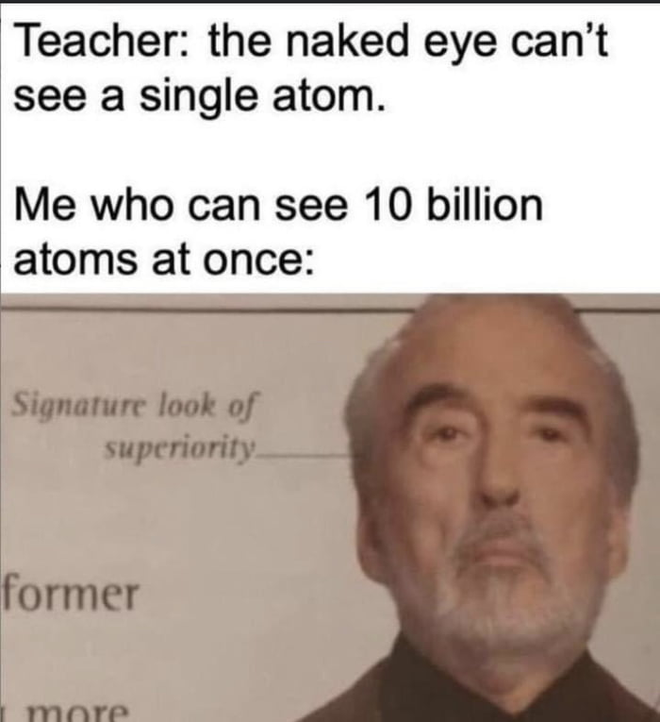

Figure : reaction meme

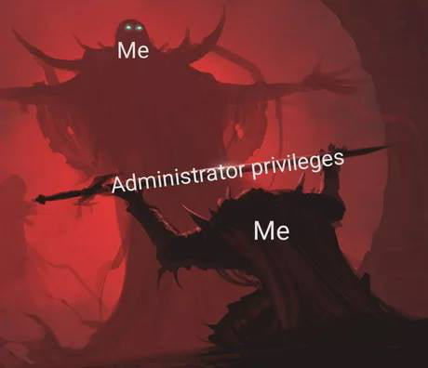

Figure : illustration meme

However, I would not use other types of memes such as the one which are jokes since they need a very accurate caption to work, such as the one below:

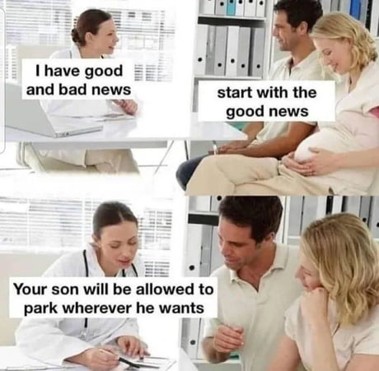

Figure : A “joke” meme

I would not generate memes which would need additional images or further work on the visual aspect of the original meme to be relevant since it would greatly complexify the technical challenge. As I said earlier, I want to focus on the creative aspect of the project and there is far enough to do without that kind of memes.



Figure : meme containing additional visual work

A meme which requires additional work on the original image. It would be far too complex to generate such kind of memes.

# 3. Technical Approach: Architectural Perspective

This software has been developed using both Unity and Tracery. I decided to use Unity since I have experience using it. In top of that, I found a plug-in to use Tracery inside a Unity project which greatly eased my work.

Basically, there are only two things that happen on a technical level.

The first one is the randomized choice of image. Internet links of these images are stored in two different ArrayList of string. The first ArrayList contains images which correspond to “illustration memes” and the second one, memes which are “situation memes”. It is important to separate those two types of memes in term of data structure as they are, on a programming level, treated differently. So, being able to call different functions and methods according to the list used has been very handy.

The other thing that happens is the grammar generation, which is obviously determined by the image that has been randomly chosen. The generated grammar will be determined by which list the image belongs to (so if it corresponds to an illustration or reaction meme). Through the Tracery plug-in, the software will “ask” for a different output.

Figure : "GenerateMeme" function is called whenever the user click on the “Discover new meme” button

On a programming level, a meme is represented by 3 properties:

* an image (randomly chosen by the machine). This image will define the other two attributes’ values
* the input given to the Tracery plug-in will depend on the image chosen. For example, if it is an image from the first list (when rand_list = 0 it is a “reaction meme”), it will ask Tracery to generate a title. While if it is an image from the second list (“an illustration meme”), it will generate words to integrate into the image.
* the last attribute is only useful for the “illustration memes” since it gives the positions at which the words must be placed on the image.

|  |
| --- |
| Meme |
| RawImage image  String traceryAttributes  GameObject[] textsLocations |



Figure 7: "Meme" class constructor

Determining *traceryAttributes* value at the creation of the instance through a dedicated function (*GetTraceryAttributes* function) allows for easy management of all necessary special cases. As this function takes as parameters the index of the list and the image, we can easily, thanks to a switch case, determine its value. This value corresponds to what is "requested" as output, so Tracery only needs to generate a result according to the *traceryAttributes*’s property.

Figure : top-level view of the system

# 4. Data, Information, Knowledge

One of the main advantages of such a project is that there is almost an infinite number of resources. The whole internet is my resource. However, for obvious reasons I must limit my area of research.

I found a website, <imgflip.com>, which collects a wide range of different memes. The big advantage of this website is that in top of having blank versions of memes, it also stores users’ creations which allows oneself to understand how it is used. So, in top of being a resource of images, it can also be an inspiration to get ideas on how to use a certain meme.

I intend to use sixty different images. Thirty illustrations and thirty situations’ memes. Reactions’ memes have only one caption which is the title while illustrations memes can have several different captions. To choose which images to pick I had two criteria in mind. The first one is that the image does not need any knowledge background to be understood. For example, if one needs to have seen a particular movie, show or video to understand it, I will exclude it. I want the generator to be as universal as possible, so I tried to pick only images that are independent from their original source to be understood. A very good example of that is the famous Pikachu meme. One does not need to have watched any Pokemon episode, nor to even know Pokemon. Indeed, the image speaks for itself, and Pikachu’s “facial expression” is talkative enough not to need any more context to be understood. This is exactly the kind of images I want to use for that project.

Figure : "Surprised Pikachu" meme given as an example of a meme that is easy to identify with

The second criteria for an image to be picked is that it needs to be unique from the other memes already picked. I tried to choose about 45 different memes that have some uniqueness in the way they depict a situation or a reaction which describes something new from the other images of the set. However, it does not mean that each meme will require a different type of output. Indeed, in this project, many images require to the Tracery grammar the same kind of output. It makes the selection process even more decisive, since it is the image and the impression it gives that will have the greatest impact on the overall impression of variety or not.

That being said, the diversity of the different themes used, and the size of their set is also an influential factor on the impression of variation. Therefore, I tried to mix different kinds of fields: cooking, philosophy, politics and every-day life.

Each with its own specificities and variations. In order to expand the various categories and the number of possibilities they cover as much as possible; I took inspiration from external sources: cooking recipe sites, lists of philosophers, countries, political figures, etc. However, simply expanding the number of possibilities is not enough to create a sense of variety. A human being will see very little difference between the same two below:

That is why, in addition to trying to expand the number of possibilities for each, I have also made it possible to mix these different themes. Doing this allows the number of possible generations to increase exponentially without having to increase the number of words (which has, in any case, its limits).

# 5. Diversity and Divergence

Fluency seems to me to be the easiest dimension to control and extend. Indeed, it is enough to simply add possibilities to increase the fluidity of the system. However, this fluidity only makes sense if the options that make it up are relevant to the goal. For this reason, *Merme Generator 3000* has a relatively small number of different possibilities. A meme can be composed of several different captions and each one should (ideally) be relevant to the others generated. It is therefore necessary to have control over the different possibilities linked to each option. This constraint limits (relatively) the diversity of generations since the greater the number of generatable elements, the more control over the other elements linked to them is required. As I said earlier in the report, for this project my goal is not to create an exhaustive a system whose outputs are almost always relevant and amusing, but to show what can be done in terms of simulating creative momentum for memes generation with simple tools and without using artificial intelligence technologies.

I think that what undermined my control over the relevance of the outputs was the fact that I was dealing with such a broad topic. Perhaps I should have done a culinary meme generator, or a political meme generator, rather than a *general* meme generator.

I don't think that would have hurt the flexibility of the project, on the contrary. Indeed, sticking to a particular subject (a relatively broad one, I mean, such as cooking or politics) would have directed my research and my thinking rather than scattering it as was the case in the project as it is. However, even if some of the outputs are sometimes very irrelevant because of the many mixed themes, not having built the system around a particular topic allows to generate astonishing outputs and to have results that could not have been thought by a human, but still make sense. From my own experience in computer creativity, it is this kind of generation that gives the most interesting results and shows the "creative" potential of machines.

Also, the strength of memes is precisely this variety, the fact that they can be used in extremely different contexts and still be relevant. Of course, limiting oneself to a single subject would have served the original purpose well, but it would have detracted from the originality of the creations. According to H. Bergson, laughter comes from the discrepancy between two elements which makes the whole incongruous:

« *You may laugh at an animal, but only because you have detected in it some human attitude or expression.*»[1]

In this example, the comedy of a situation is given by the discrepancy between the expected behaviour of the animal and the human behaviour, which is conceived as being opposite. Seeing an animal behave like a human (wearing clothes or eating while sitting at a table) therefore provokes laughter. This is sometimes simulated by *Merme Generator 3000* and is even stronger and more obvious when themes are mixed:

Figure : shift created by the presence of philosophical and family references

In this output, there is a gap between “my grandma” and philosophers. Imagining "my grandmother” mocking Kant with Bergson implies that she is in the same field and on the same intellectual plane as them. No matter how is my grandma or your grandma. What matters here is the general idea of *grandma*, what a grandmother is like from a caricature point of view. It is this general idea of *grandma* and the general idea of what a philosopher is and the gap between these two ideas which is important.

**Elaboration**

# 6. “Mere” Generation and “True” Creativity

As I mentioned earlier, the outputs of this project are very controlled, which makes the results predictable, and not surprising. It always follows the (strict) rules I impose on it. When a result is generated, it corresponds to the imposed rules and is therefore considered valid without any further verification.

The way the system approaches a creation is very different from the way a human would. This system has a reverse temporality to that of a human being creating a meme.

Indeed, a human being would experience a situation or make a reflection and would have the idea to illustrate it with a meme. For example, let's say I'm driving a car with my father as a passenger. He is very prescriptive about how to drive and adamant about how I should behave on the road while he himself drives dangerously. I am experiencing this situation and it makes me think of a meme that could fit the situation. I want to illustrate this moment with the help of this meme. I choose an image because it fits the scene I am experiencing and the way I want to portray it.

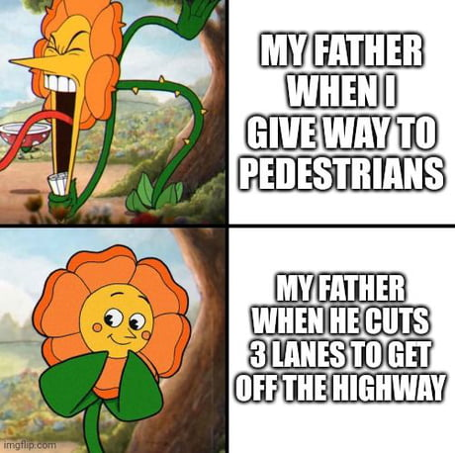

Figure : meme that could be created by a human AFTER living a specific situation

This thought process ensures that the creation will be relevant since it is the situation that calls for the meme.

However, in this project, the temporality is the opposite: the program first chooses an image and THEN determines the way it will be captioned.

This temporality is the main difference between a human being and my system when it comes to creating a meme. However, the system has a similar way of doing things to a human being who is given an image to illustrate. A human would analyse the image, understands the areas to be captioned and try to find things he knows about the different elements of the image to illustrate.

Figure : meme created by a human FOLLOWING a given template

We can see that this meme, whose template has been imposed, has a much more universal and relatable theme than the one shown above. This shows that as the creative system, when an image is imposed to someone, a human being will spontaneously go towards common and unoriginal situations.

This is what *Merme Generator 3000* does, even if the field of what it knows and can therefore associate with a meme is much more limited than a human who has decades of experience.

The originality and novelty in memes often come from the experience of the creative subject. Obviously, it can not be simulated in such a project. I would probably need to call for artificial intelligence technologies to be able to reproduce such a behavior.

# 7. Evaluation, Self-Critique and Filtering

This project is more complex from the point of view of grammar work than I thought when I designed it. Indeed, linking variety and relevance requires a lot of testing and a lot of different types of output. However, as I mentioned earlier in this report, it might have been more relevant to reduce the number of possible images and "restrict" yourself to a single theme, such as cooking for example (although the advantages of including more than one have been widely discussed).

# 8. Hits and Misses

As a meme-enthusiast, I find many of the outputs generated to be funny or relevant. The fact that they are created by a machine makes some memes funnier than they would have been if they had been created by a human. Let's look at the meme below for example.

Figure : meme about Bill Clinton

This one is funny (at least to me) because it assumes machine intent. Out of all the possible people and actions, these were chosen and clearly echo one of the things related to Bill Clinton's person. A human being is assumed to know this thing, but not a machine. The fact that the machine randomly generates such an output may give the impression that Bill Clinton is quasi-metaphysically linked to such things. It's not funny because of what is explicitly written, but because of what it implies about the character.

# 9. Conclusions

Working on this project made me realize how relevant it is: I have understood why so many outputs were funny while they are completely random. The fact that the outputs are generated by a machine is funny in its own way. We humans have a reflex to look for patterns in what we experience. Therefore, for example we are so good at spotting face shapes in nature. And that is also why this project works well: even though there is no intention from the machine to do something funny or even meaningful, when a new output is generated, we try to find a meaning to it. Of course, it is not always obvious nor possible, but what I have personally experienced is that it is often the case. I think that this project, or at least this idea was worth to be worked on in a “mere generation” perspective in that sense. At least, this is what I have understood and retained from this module.

I would like to conclude that report by thanking the whole internet for its imagination and for being able to create such an amazing content that never cease to amaze me! Thank you, internet user!

# Acknowledgements

I acknowledge that the work is entirely my own and that every sentence in this report has been written by me and myself only, except where explicitly stated.

# References

New World Encyclopedia (2019) J.P Guilford, Available at: <https://www.newworldencyclopedia.org/entry/J._P._Guilford>

[Accessed: 27/04/2022]

Bergson, H., Laughter: An Essay on the Meaning of the Comic

1. Bergson, H., Laughter: An Essay on the Meaning of the Comic